**UNIT – 3 (Muscular Work & Nervous Control of Movements)**

**Muscular work in Occupational Activities:**

The work done by a muscle through the power of contraction is known as muscular work. A muscle fiber generates tension when properly stimulated, by the nervous system or by electrical impulses. This physiological process is called muscle contraction. Muscle fiber generates tension through the action of actin and myosin cross-bridge cycling. While under tension, the muscle may lengthen, shorten, or remain the same. Although the term contraction implies shortening, when referring to the muscular system, it means muscle fibers generating tension with the help of motor neurons. Several types of muscle contractions occur and they are defined by the changes in the length of the muscle during contraction.

In industrialized countries around 20% of workers are still employed in jobs requiring muscular effort. The number of conventional heavy physical jobs has decreased, but, on the other hand, many jobs have become more static, asymmetrical and stationary. In developing countries, muscular work of all forms is still very common.

**Types of Muscular Work:**

Muscular work in occupational activities can be roughly divided into four groups: heavy dynamic muscle work, manual materials handling, static work and repetitive work. Heavy dynamic work tasks are found in forestry, agriculture and the construction industry, for example – Materials handling is common, for example, in nursing, transportation and warehousing, while static loads exist in office work, the electronics industry and in repair and maintenance tasks. Repetitive work tasks can be found in the food and wood-processing industries, for example.

It is important to note that manual materials handling and repetitive work are basically either dynamic or static muscular work, or a combination of these two.

**Dynamic muscular work:**

In dynamic work, active skeletal muscles contract and relax rhythmically. The blood flow to the muscles is increased to match metabolic needs. The increased blood flow is achieved through increased pumping of the heart (cardiac output), decreased blood flow to inactive areas, such as kidneys and liver, and increased number of open blood vessels in the working musculature. Heart rate, blood pressure, and oxygen extraction in the muscles increase linearly in relation to working intensity. Also, pulmonary ventilation is heightened owing to deeper breathing and increased breathing frequency. The purpose of activating the whole cardio-respiratory system is to enhance oxygen delivery to the active muscles. The level of oxygen consumption measured during heavy dynamic muscle work indicates the intensity of the work. The maximum oxygen consumption (VO**2max**)indicates the person’s maximum capacity for aerobic work. Oxygen consumption values can be translated to energy expenditure (1 litre of oxygen consumption per minute corresponds to approximately 5 kcal/min or 21 kJ/min). In the case of dynamic work, when the active muscle mass is smaller (as in the arms), maximum working capacity and peak oxygen consumption are smaller than in dynamic work with large muscles. At the same external work output, dynamic work with small muscles elicits higher cardio-respiratory responses (e.g., heart rate, blood pressure) than work with large muscles. See the figure 1.

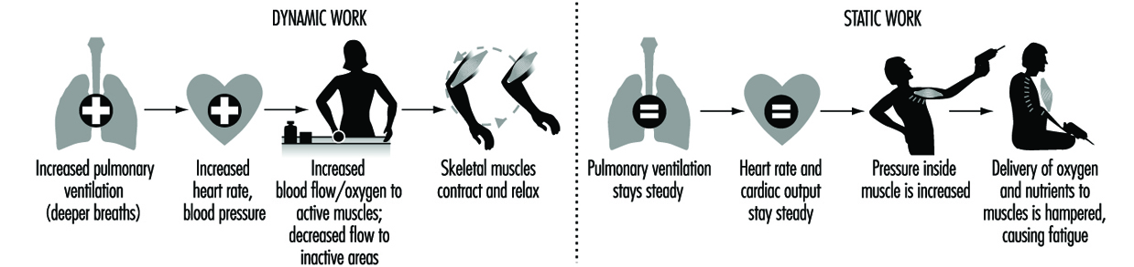

Figure 1

**Static muscle work**

In static work, muscle contraction does not produce visible movement, as, for example, in a limb. Static work increases the pressure inside the muscle, which together with the mechanical compression occludes blood circulation partially or totally. The delivery of nutrients and oxygen to the muscle and the removal of metabolic end-products from the muscle are hampered. Thus, in static work, muscles become fatigued more easily than in dynamic work.

The most prominent circulatory feature of static work is a rise in blood pressure. Heart rate and cardiac output do not change much. Above a certain intensity of effort, blood pressure increases in direct relation to the intensity and the duration of the effort. Furthermore, at the same relative intensity of effort, static work with large muscle groups produces a greater blood pressure response than does work with smaller muscles. See figure 2.

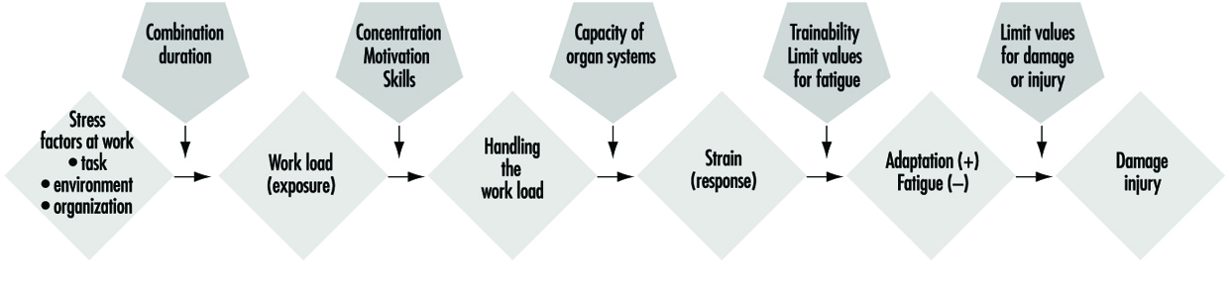

Figure 2 The expanded stress-strain model modified from Rohmert (1984)

**Consequences of Muscular Overload in Occupational Activities:**

The degree of physical strain a worker experiences in muscular work depends on the size of the working muscle mass, the type of muscular contractions (static, dynamic), the intensity of contractions, and individual characteristics.

When muscular workload does not exceed the worker’s physical capacities, the body will adapt to the load and recovery is quick when the work is stopped. If the muscular load is too high, fatigue will ensue, working capacity is reduced, and recovery slows down. Peak loads or prolonged overload may result in organ damage (in the form of occupational or work-related diseases). On the other hand, muscular work of certain intensity, frequency, and duration may also result in training effects, as, on the other hand, excessively low muscular demands may cause detraining effects. These relationships are represented by the so-called expanded stress-strain concept developed by Rohmert (1984) (figure 3).

**Prevention of Muscular Overload:**

Muscular overload is harmful to health. However, work physiological and ergonomic studies indicate that muscular overload results in fatigue (i.e., decrease in work capacity) and may reduce productivity and quality of work.

The prevention of muscular overload may be directed to the work content, the work environment and the worker. The load can be adjusted by technical means, which focus on the work environment, tools, and/or the working methods. The fastest way to regulate muscular workload is to increase the flexibility of working time on an individual basis. This means designing work-rest regimens which take into account the workload and the needs and capacities of the individual worker.

Static and repetitive muscular work should be kept at a minimum. Occasional heavy dynamic work phases may be useful for the maintenance of endurance type physical fitness. Probably, the most useful form of physical activity that can be incorporated into a working day is brisk walking or stair climbing.

Prevention of muscular overload, however, is very difficult if a worker’s physical fitness or working skills are poor. Appropriate training will improve working skills and may reduce muscular loads at work. Also, regular physical exercise during work or leisure time will increase the muscular and cardio-respiratory capacities of the worker.

**Acceptable Workload in Heavy Dynamic Muscular Work**

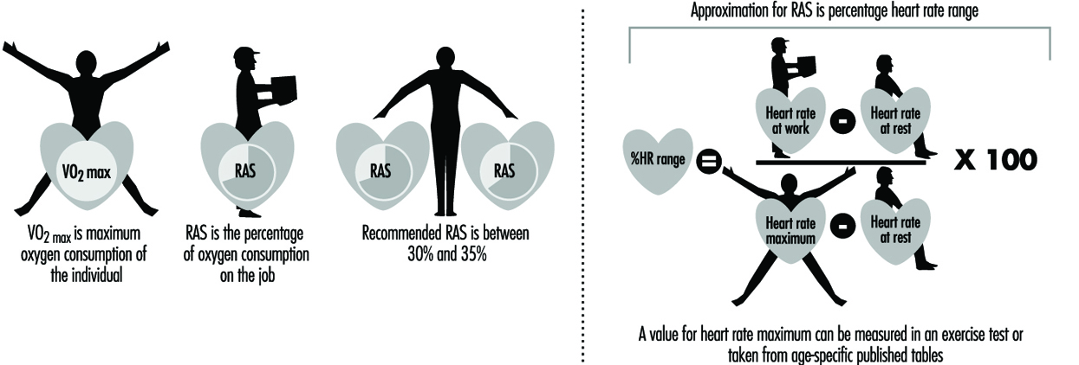

Figure 3 Analysis of acceptable workloads

The assessment of acceptable workload in dynamic work tasks has traditionally been based on measurements of oxygen consumption. Oxygen consumption can be measured with relative ease in the field with portable devices or it can be estimated from heart rate recordings, which can be made reliably at the workplace, for example, with the SportTester device. The use of heart rate in the estimation of oxygen consumption requires that it be individually calibrated against measured oxygen consumption in a standard work mode in the laboratory, i.e., the investigator must know the oxygen consumption of the individual subject at a given heart rate. . Thus, heart rate measurements can lead to overestimates of oxygen consumption in the same way that oxygen consumption values can give rise to underestimates of global physiological strain by reflecting only energy requirements.

Relative aerobic strain (RAS) is defined as the fraction (expressed as a percentage) of a worker’s oxygen consumption measured on the job relative to his or her VO**2max**measured in the laboratory. If only heart rate measurements are available, a close approximation to RAS can be made by calculating a value for percentage heart rate range (% HR range) with the so-called Karvonen formula as in figure 3

According to Åstrand’s (1960) classical study, RAS should not exceed 50% during an eight-hour working day. In her experiments, at a 50% workload, body weight decreased, heart rate did not reach steady state and subjective discomfort increased during the day. She recommended a 50% RAS limit for both men and women. Later on she found that construction workers spontaneously chose an average RAS level of 40% (range 25-55%) during a working day. Several more recent studies have indicated that the acceptable RAS is lower than 50%. Most authors recommend 30-35% as an acceptable RAS level for the entire working day.

**Acceptable Workload in Manual Materials Handling:**

Manual materials handling includes such work tasks as lifting, carrying, pushing and pulling of various external loads. Most of the research in this area has focused on low back problems in lifting tasks, especially from the biomechanical point of view.A RAS level of 20-35% has been recommended for lifting tasks, when the task is compared to an individual maximum oxygen consumption obtained from a bicycle ergometer test.

It is very difficult to set any definitive criteria for repetitive work, because even very light levels of work (as with the use of a microcomputer mouse) may cause increases in intramuscular pressure, which may sometimes lead to swelling of muscle fibres, pain and reduction in muscle strength.

Repetitive and static muscle work will cause fatigue and reduced work capacity at very low relative force levels.

**Muscular Fatigue:**

Muscle fatigue can be defined as exercise-induced decrease in the ability to produce force. It is the overwhelming sense of tiredness, lack of energy and feeling of exhaustion, fatigue relates to a difficulty in performing voluntary tasks. It is a symptom that decreases your muscles’ ability to perform over time. It can be associated with a [state of exhaustion](https://www.healthline.com/symptom/fatigue). On experience fatigue, the force behind your muscle’s movement decreases, causing you to feel weaker. Fatigue accumulation, if not resolved, leads to overwork, chronic fatigue syndrome (CFS), overtraining syndrome, and even endocrine disorders, immunity dysfunction, organic diseases and a threat to human health.

There are many different fatigue classification methods. According to its duration, fatigue can be classified into acute fatigue and chronic fatigue. Acute fatigue can be quickly relieved by rest or life-style changes, whereas chronic fatigue is a condition defined as a persistent tiredness lasting months that is not ameliorated by rest. Fatigue can also be classified as mental fatigue, which refers to the cognitive or perceptual aspects of fatigue, and physical fatigue, which refers to the performance of the motor system.

**Muscle fatigue symptoms**

Muscle fatigue can occur anywhere on the body. An initial sign of this condition is [muscle weakness](https://www.healthline.com/symptom/muscle-weakness). Other symptoms associated with muscle fatigue include:

* [soreness](https://www.healthline.com/health/5-recovery-tips-prevent-muscle-soreness)
* [localized pain](https://www.healthline.com/symptom/muscle-pain)
* [shortness of breath](https://www.healthline.com/symptom/shortness-of-breath)
* [muscle twitching](https://www.healthline.com/symptom/muscle-twitch)
* [trembling](https://www.healthline.com/symptom/tremor)
* a weak grip
* [muscle cramps](https://www.healthline.com/symptom/muscle-cramp)

If you begin having difficulty performing daily tasks or if your symptoms worsen, seek immediate medical attention. This could be an indication of a more serious health condition.

**Treating muscle fatigue**

Treatment depends on the underlying cause of your muscle fatigue and accompanying symptoms. If you’ve been experiencing muscle fatigue, especially if it’s unrelated to exercise, call your doctor. Your doctor will evaluate your medical history and symptoms to rule out more serious health conditions.

In many cases, your muscle fatigue will improve with rest and recovery. Staying [hydrated](https://www.healthline.com/nutrition/7-health-benefits-of-water) and [maintaining a healthy diet](https://www.healthline.com/nutrition/14-ways-to-stick-to-a-diet) can also improve your recovery time, protect against muscle fatigue and weakness, and ensure you have enough nutrients to promote healthy muscle function.

Be sure to [stretch](https://www.healthline.com/health/fitness-exercise-stretching) before and after strenuous activity. Warming up can loosen your muscles and protect against injury. If your muscle fatigue persists, [hot and cold therapy](https://www.healthline.com/health/chronic-pain/treating-pain-with-heat-and-cold) is one of the best techniques that can reduce inflammation and discomfort.

Other cases of muscle fatigue may require medical attention. Depending on your diagnosis, your doctor may prescribe anti-inflammatory or antidepressant medications. If your muscle fatigue is more severe, you doctor may recommend physical therapy to increase your mobility and speed your recovery.

Caffeine can help to reduce muscle fatigue after several types of exercise, such as running or weight training. [Ginseng](https://www.medicalnewstoday.com/articles/262982.php) is a herb with several possible health benefits, such as relieving muscle fatigue. red ginseng can improve muscle performance in people during weight training.

 Using the ergogenic aids, such as [creatine](https://www.medicalnewstoday.com/articles/263269.php) helps to improve muscle performance. Red meat and seafood are one of the best sources of creatine.

**Types of Muscle Contractions:**

Muscle fiber generates tension through the action of actin and myosin cross-bridge cycling. While under tension, the muscle may lengthen, shorten, or remain the same. Although the term contraction implies shortening, when referring to the muscular system, it means muscle fibers generating tension with the help of motor neurons. Several types of muscle contractions occur and they are defined by the changes in the length of the muscle during contraction. Refer Figure 4.

**Isotonic Contractions**

Isotonic contractions maintain constant tension in the muscle as the muscle changes length. This can occur only when a muscle’s maximal force of contraction exceeds the total load on the muscle. Isotonic muscle contractions can be either concentric (muscle shortens) or eccentric (muscle lengthens).

**Concentric Contractions**

A concentric contraction is a type of muscle contraction in which the muscles shorten while generating force. This is typical of muscles that contract due to the sliding filament mechanism, and it occurs throughout the muscle. Such contractions also alter the angle of the joints to which the muscles are attached, as they are stimulated to contract according to the sliding filament mechanism.

This occurs throughout the length of the muscle, generating force at the musculo-tendinous junction; causing the muscle to shorten and the angle of the joint to change. For instance, a concentric contraction of the biceps would cause the arm to bend at the elbow as the hand moves from near to the leg to close to the shoulder (a biceps curl). A concentric contraction of the triceps would change the angle of the joint in the opposite direction, straightening the arm and moving the hand toward the leg.

**Eccentric Contractions**

An eccentric contraction results in the elongation of a muscle. Such contractions decelerate the muscle joints (acting as “brakes” to concentric contractions) and can alter the position of the load force. These contractions can be both voluntary and involuntary. During an eccentric contraction, the muscle elongates while under tension due to an opposing force which is greater than the force generated by the muscle. Rather than working to pull a joint in the direction of the muscle contraction, the muscle acts to decelerate the joint at the end of a movement or otherwise control the repositioning of a load.

This can occur involuntarily (when attempting to move a weight too heavy for the muscle to lift) or voluntarily (when the muscle is “smoothing out” a movement). Over the short-term, strength training involving both eccentric and concentric contractions appear to increase muscular strength more than training with concentric contractions alone.

## Isometric Contractions

In contrast to isotonic contractions, isometric contractions generate force without changing the length of the muscle. This is typical of muscles found in the hands and forearm: the muscles do not change length, and joints are not moved, so force for grip is sufficient. An example is when the muscles of the hand and forearm grip an object; the joints of the hand do not move, but muscles generate sufficient force to prevent the object from being dropped.

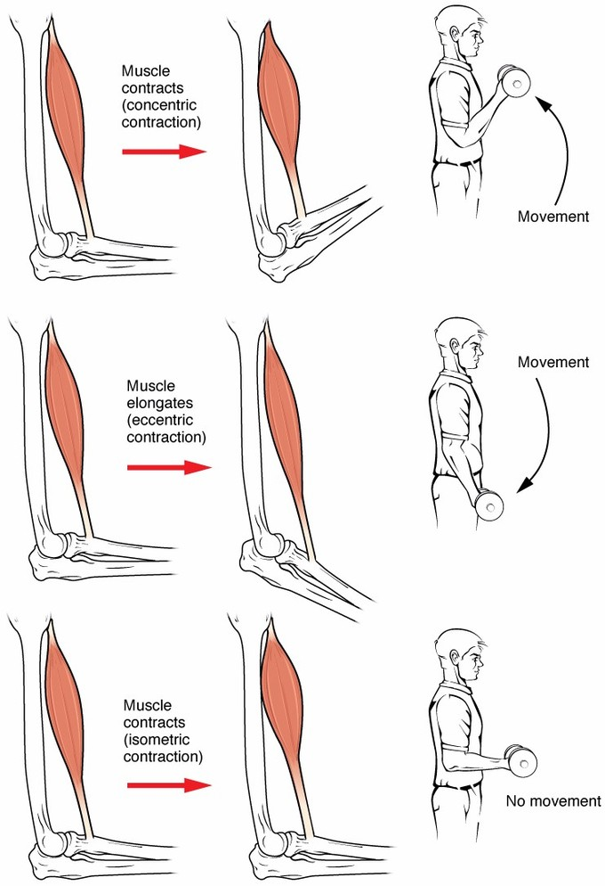

Figure 4 Types of muscle contractions

**Measurement of muscular strength:**

Resistance tests: It is the maximum load or weight that the athlete can lift

once and called the maximum repetition once. Weight is used in this measurement or

body weight and there are also many modern devices that perform the same purpose,

which specializes in measuring the muscle strength of a specific game. Measuring

strength by lifting the maximum weight is possible and is one of the most used tests

and it depends on central contraction.

Resistance tests: It is the maximum load or weight that the athlete can lift

once and called the maximum repetition once. Weight is used in this measurement or

body weight and there are also many modern devices that perform the same purpose,

which specializes in measuring the muscle strength of a specific game. Measuring

strength by lifting the maximum weight is possible and is one of the most used tests

and it depends on central contraction.

Resistance tests: It is the maximum load or weight that the athlete can lift

once and called the maximum repetition once. Weight is used in this measurement or

body weight and there are also many modern devices that perform the same purpose,

which specializes in measuring the muscle strength of a specific game. Measuring

strength by lifting the maximum weight is possible and is one of the most used tests

and it depends on central contraction.

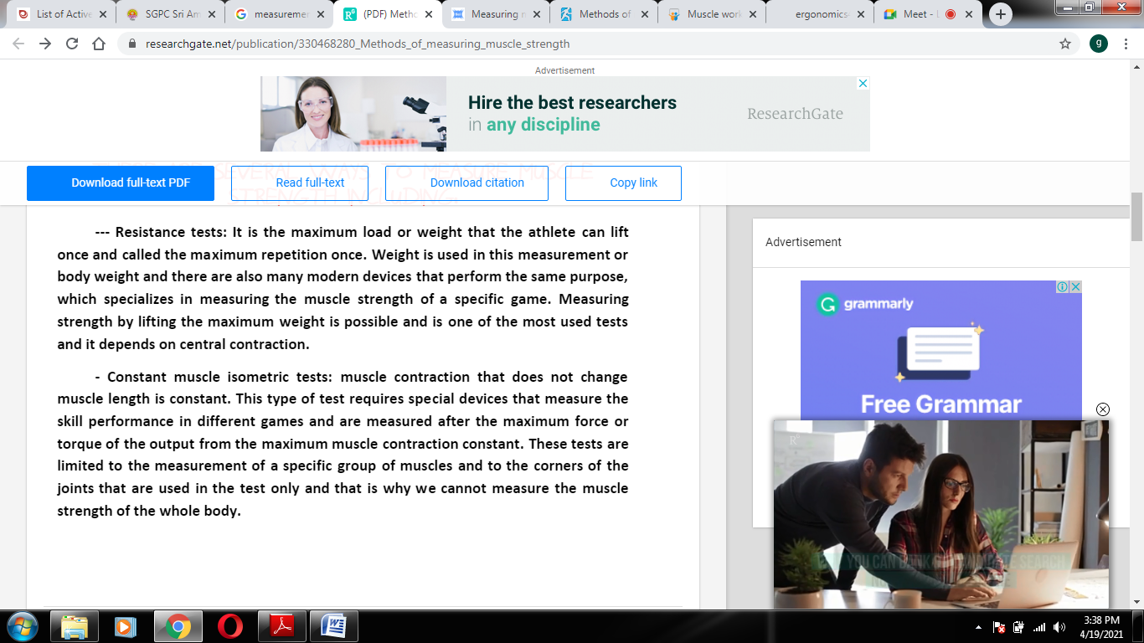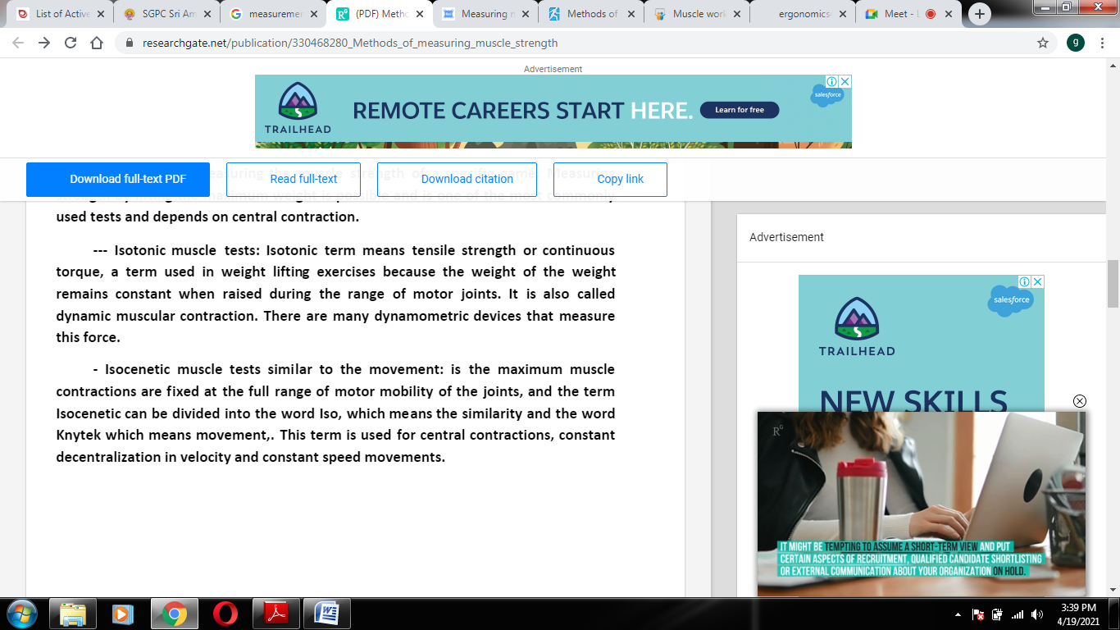

**Problems in measuring Muscle strength:**

